2. The online hotel room booking website allows users to search for hotels based on destination, dates, and number of guests, offering detailed listings with room options, prices, amenities, and reviews. Users can create accounts, log in, and manage their bookings through a user-friendly dashboard. The booking process includes checking room availability, filling out a booking form, and completing secure payments via an integrated payment gateway. Post- booking, users receive confirmation emails and can leave reviews and ratings. Admins manage hotel listings, room availability, and user accounts through a dedicated admin panel. The website is fully responsive, ensuring seamless access on all devices.
Functionalities:
Users.
1. Users can register at the hotel and then they can view or modify their profile.
2. Users can book a room on any specific date.
3. Users can view all their booking history at the hotel.
4. Users can change the booking at any time 3 days before the arrival date.
5. Users can cancel the booking at any time 3 days before the arrival date.
6. Users can check the room availability at the hotel before they book a room.
Administrator
7. Administrators can change the quantity and price of all four types of rooms.
8. Administrators can change any specific booking details.
9. Administrators can cancel any specific booking.
10. Administrators can modify the details of static pages including room information, about us information, contact us information, customer service Q&A details, local travel and shipping guide, and privacy policy after login.
11. It should also contain a basic room type introduction, contact information, customer serviceQ&A, local travel and shipping guide, and a privacy policy

SAMPLE CODE
<!DOCTYPE html>
<html>
<head>
<title>Hotel Booking</title>
</head>
<body>
<h1>Seaside Hotel</h1>
<h2>Search Rooms</h2>
<label>Check-in: <input type="date" id="checkin"></label>
<label>Check-out: <input type="date" id="checkout"></label>
<button onclick="searchRooms()">Search</button>
<div id="results"></div>
<script>
const rooms = [
{ type: "Standard", price: 2500 },
{ type: "Deluxe", price: 4000 },
{ type: "Family", price: 6000 },
{ type: "Suite", price: 8500 }
];
function searchRooms() {
const checkin = document.getElementById("checkin").value;
const checkout = document.getElementById("checkout").value;
const results = document.getElementById("results");

if (!checkin || !checkout || checkout <= checkin) {
results.innerHTML = "<p>Please enter valid dates.</p>";
return;
}
results.innerHTML = "<h2>Available Rooms</h2>";
rooms.forEach(room => {
results.innerHTML += `
<p>
${room.type} Room — ₹${room.price} per night
<button onclick="bookRoom('${room.type}')">Book</button>
</p>`;
});
}
function bookRoom(roomType) {
alert(roomType + " room booked! Payment is simulated.");
}
</script>
</body>
</html>

SAMPLE OUTPUT
GUEST VIEW
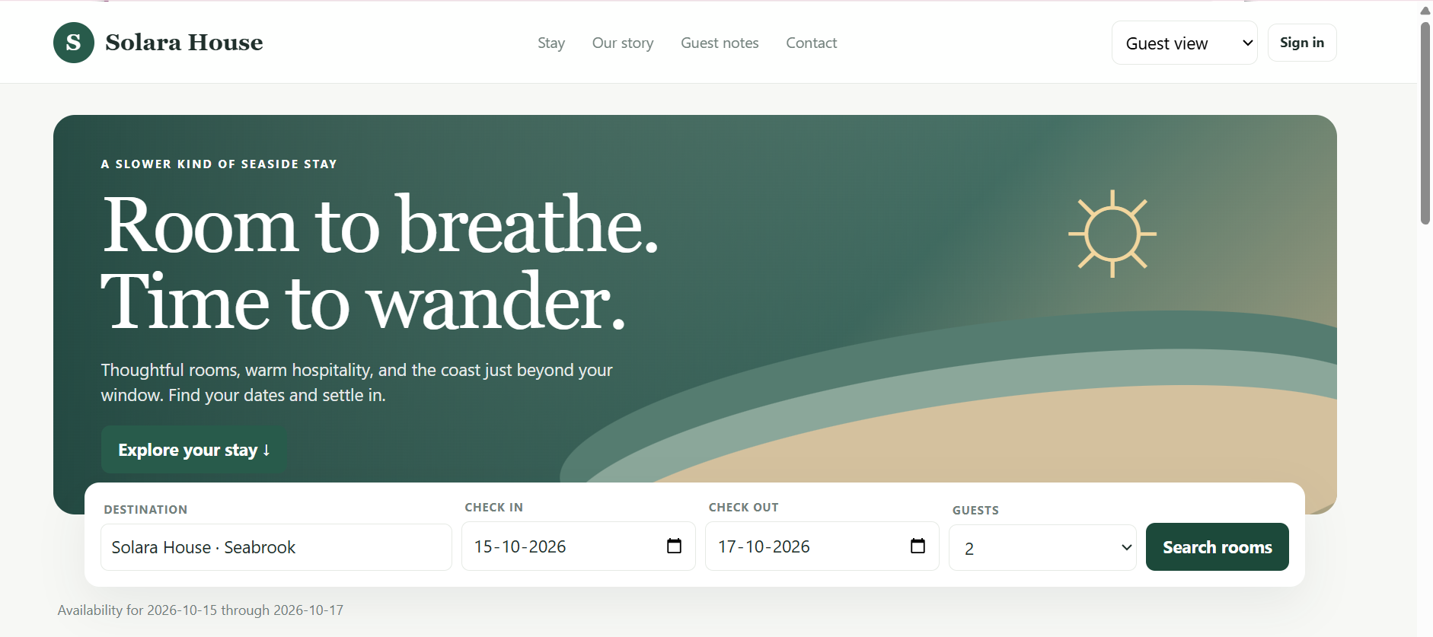
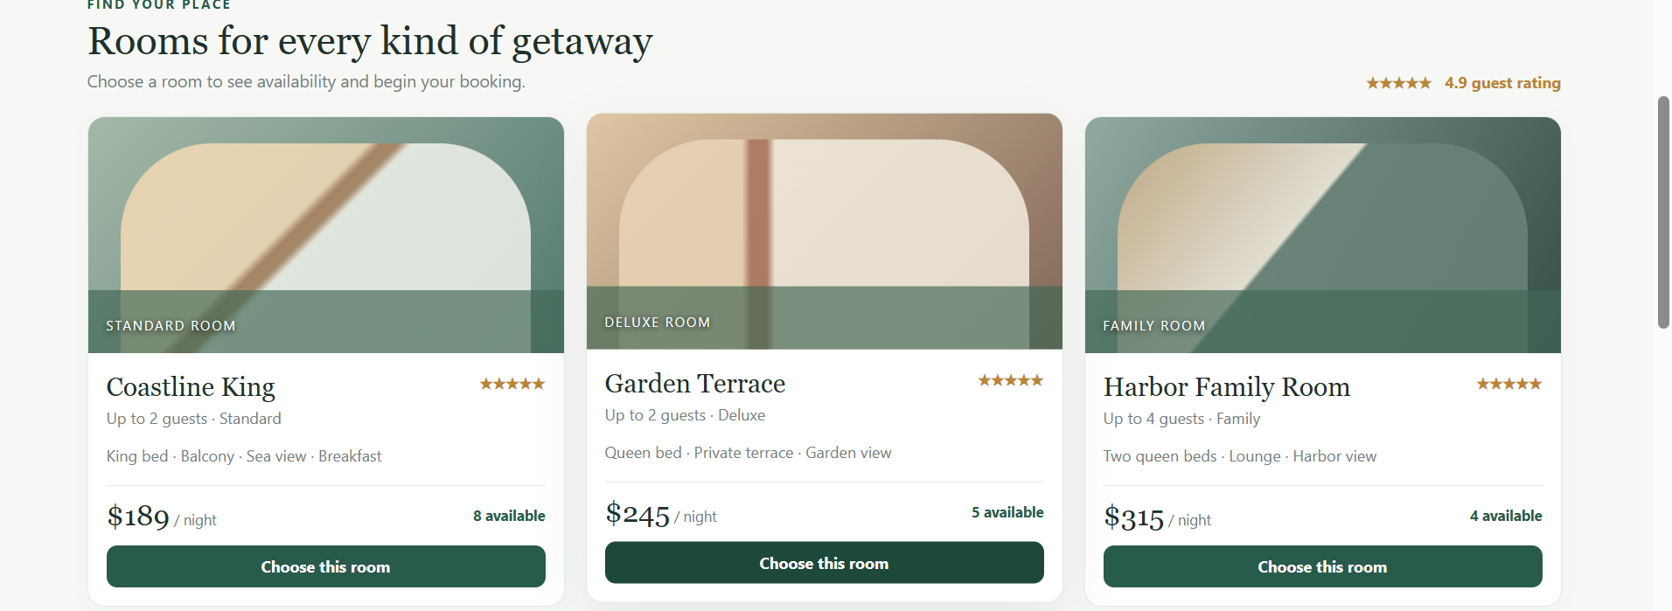
ADMINISTOR VIEW
